**Lesson 06 Demo 02**

**Implementing Framework Migration Using Generative AI**

**Objective:** To migrate the login functionality of a social media platform from Angular to Flask using a generative AI tool

**Tools required:** Visual Studio, Python, Node JS, Post man plugin and GitHub Copilot

**Prerequisites:** installed python and node js in your machine

Steps to be followed:

1. Implement a Rest API using python with flask.
2. Migrate the Python Flask to express JS

**Step 1: Implement a Rest API using python with flask**

* 1. Download the sample folder Python_Flask_Rest_Product_API and open this folder in VS code editor.
  2. The project structure in VS Code

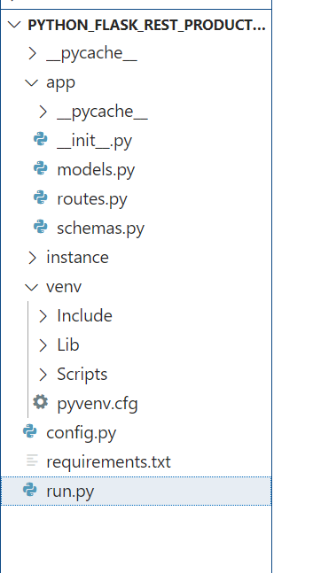

* 1. Installed required dependencies and create virtual environment

**python -m venv venv**

**On Non Window use : source venv/bin/activate #**

**On Windows use: venv\Scripts\activate**

**pip install -r requirements.txt**

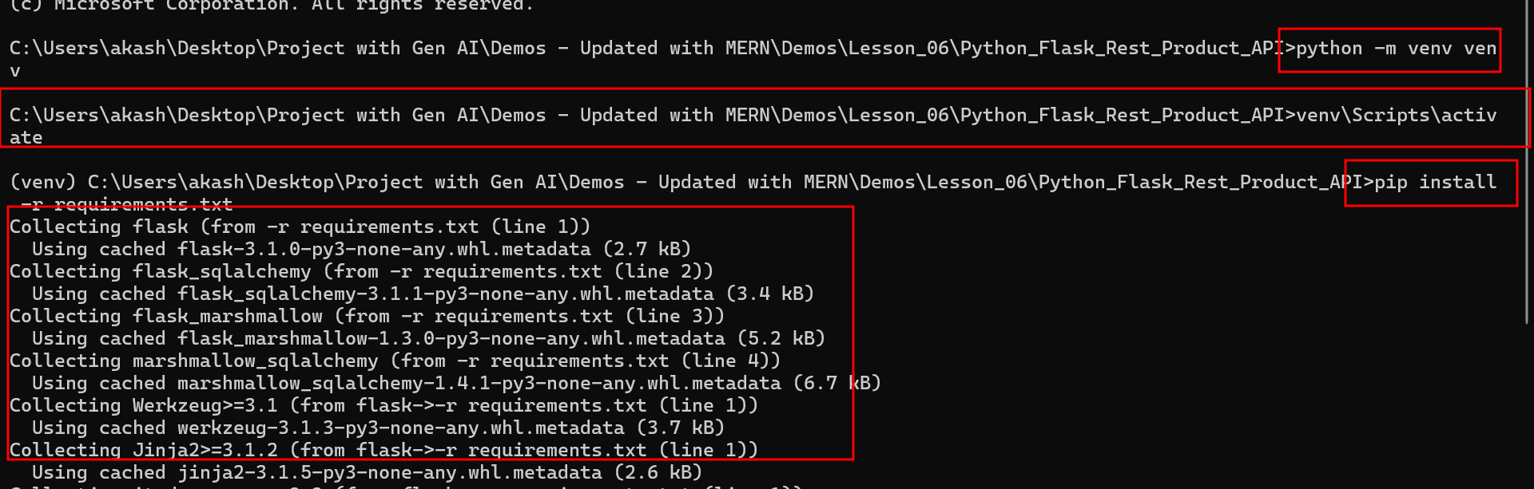

* 1. run the application

**python run.py**

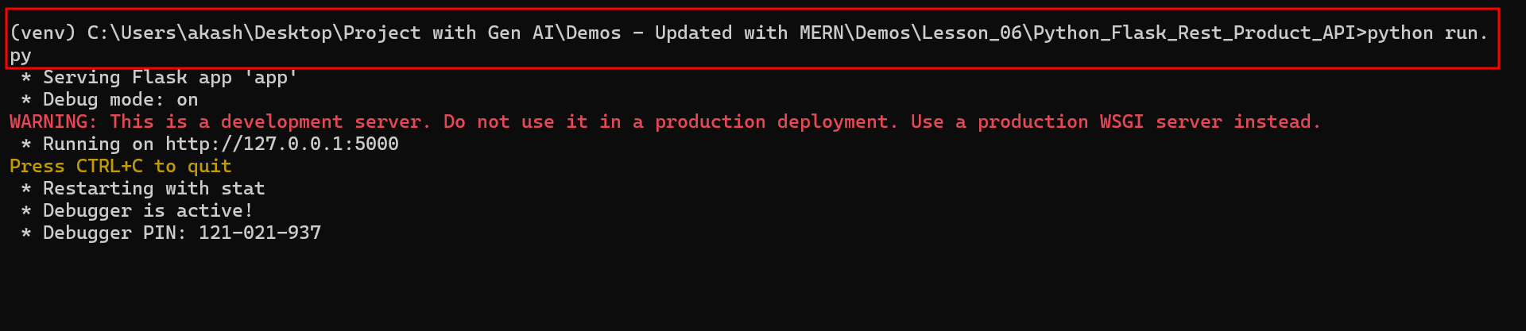

* 1. test end point using post man client plugin open the VS Code
  2. Store Product details.

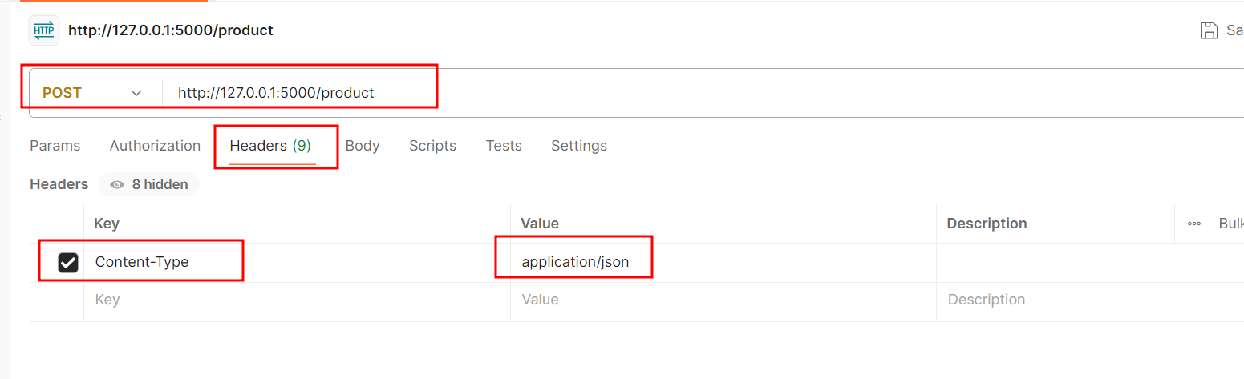

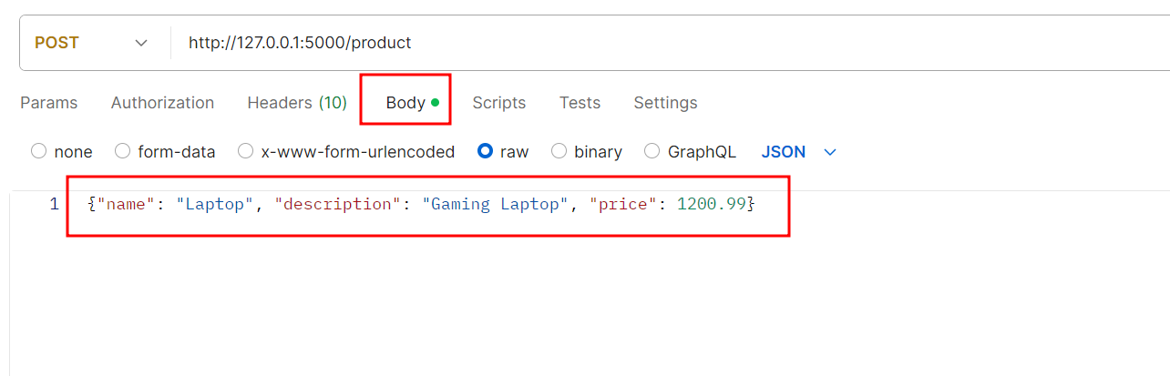

Store few products details

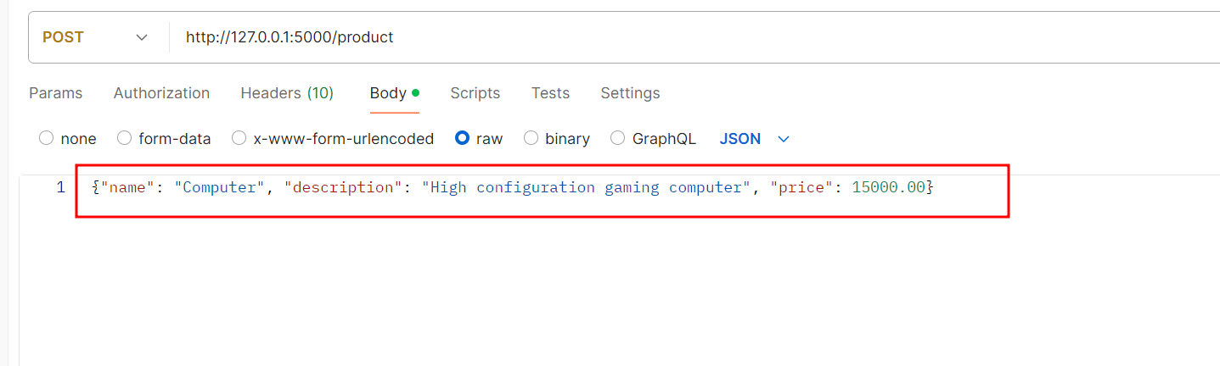

* 1. view all products

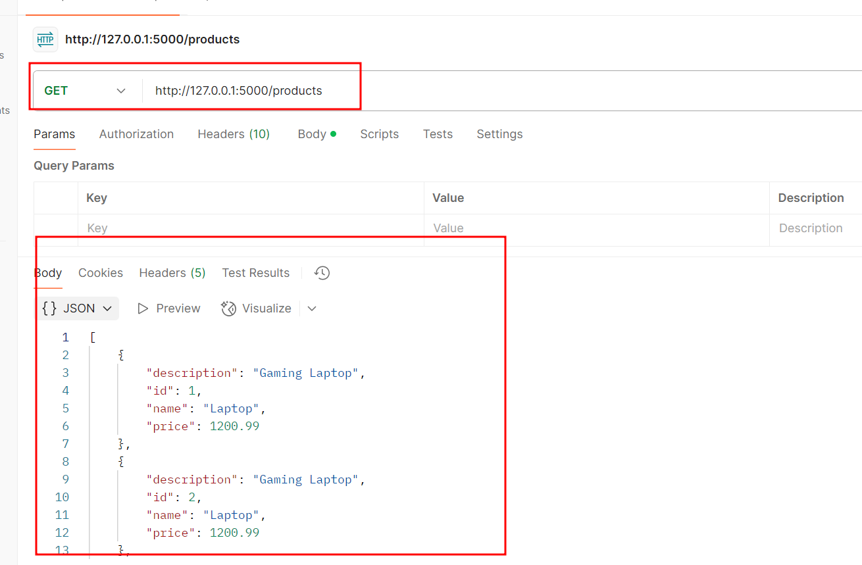

* 1. Get particular product details

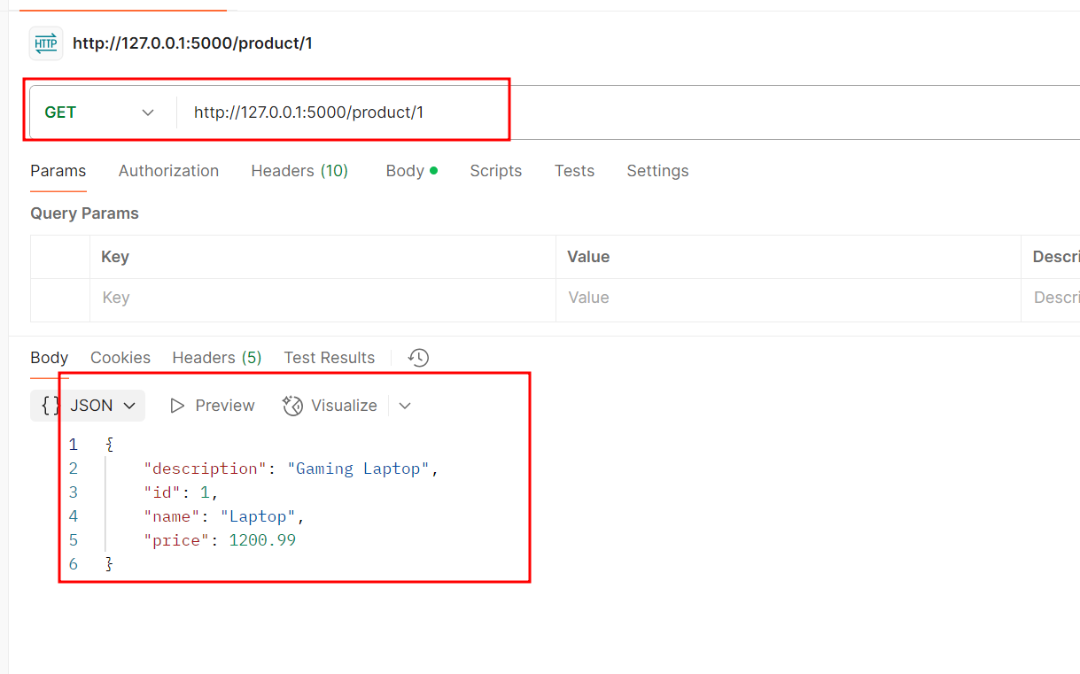

* 1. update the product details

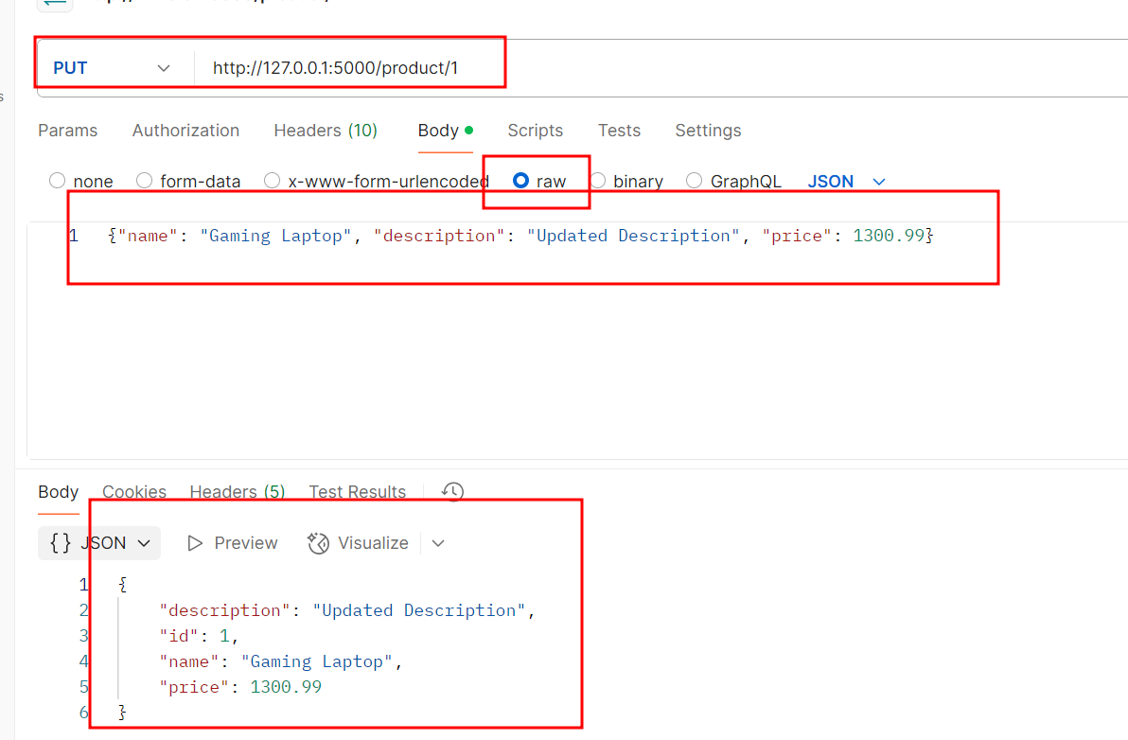

1.20 delete the product details

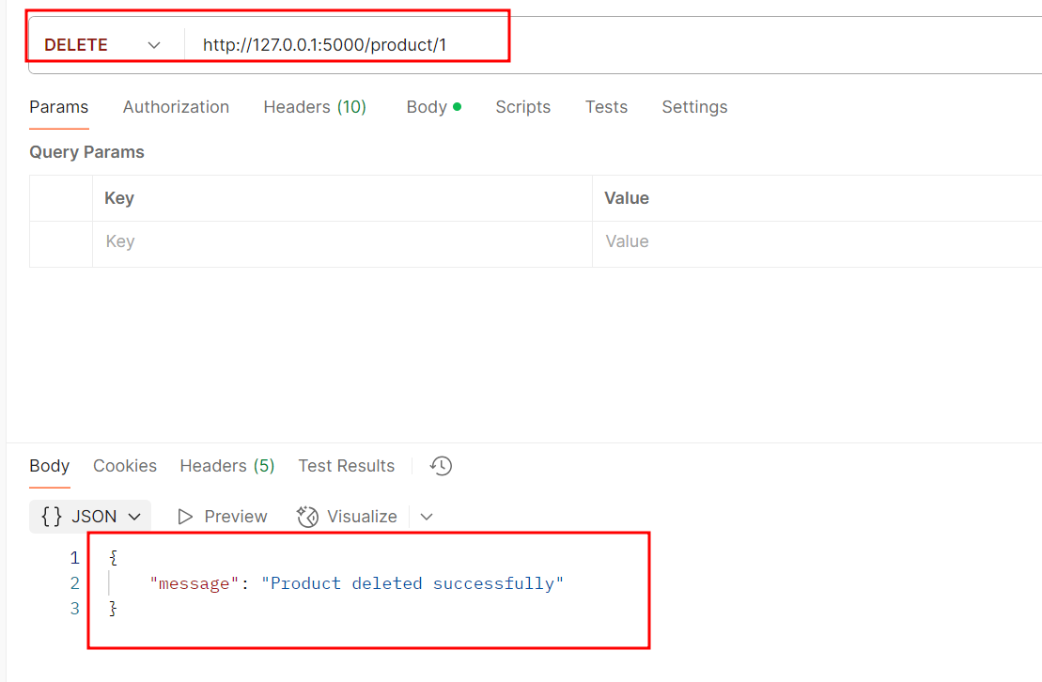

**Step 2: Migrate the Python Flask to Express Node framework**

* 1. Prompt GitHub Copilot in my-angular-app workspace to migrate from the Angular framework into the Python Flask

**Please migrate the Python flask application to Express node framework code with step by step explanation with sqllite database**

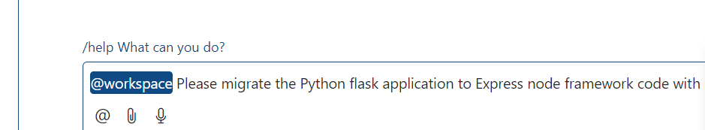

* 1. Here you can see the prompt message with project structure with code. Follow all those steps to make the complete code.
  2. After project structure ready

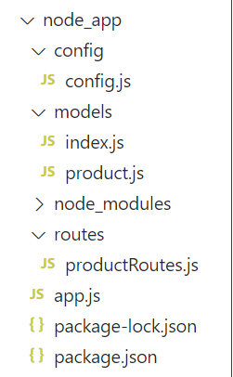

* 1. Initialize the Node.js Project

Make sure the terminal open inside node_app folder

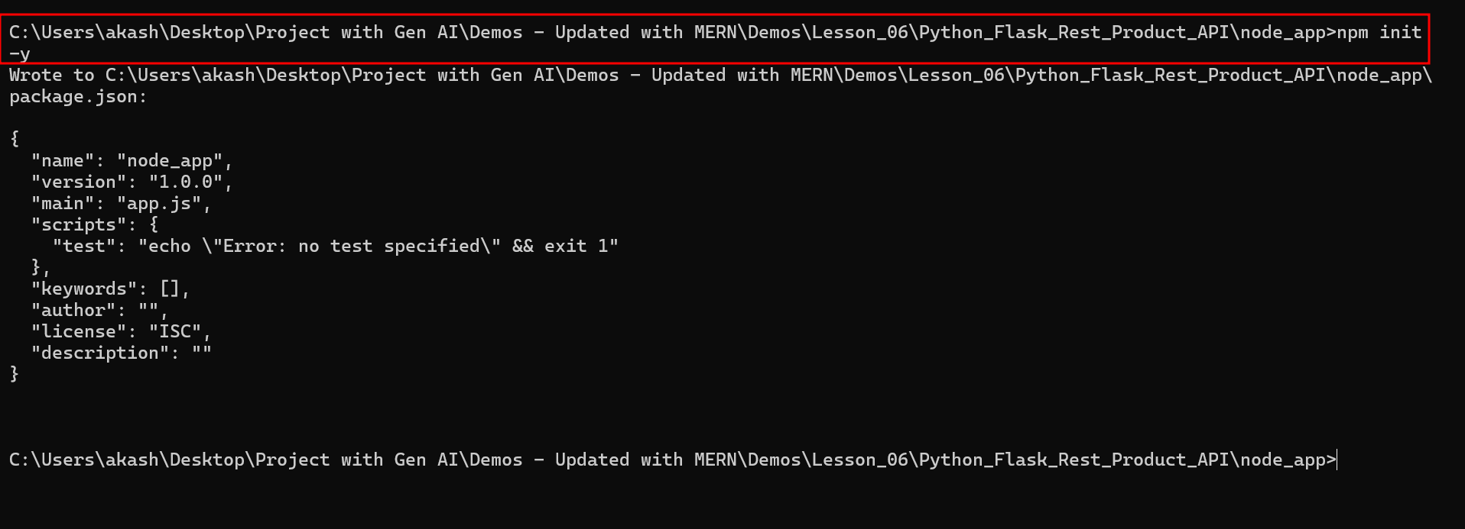

* 1. Install the necessary dependencies:

**npm install express sqlite3 sequelize body-parser**

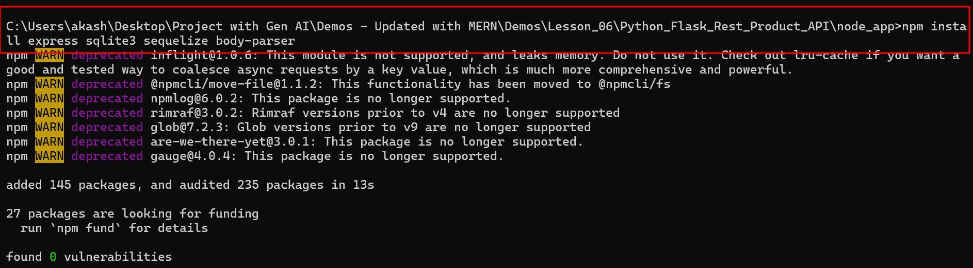

* 1. apply each file code the empty file

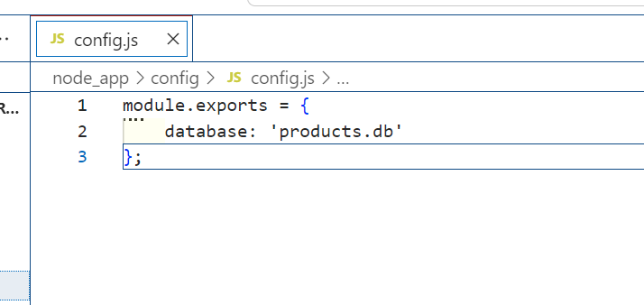

* 1. after copied all code
  2. you can run the application using below command as

**node app.js**

* 1. store the data

First set the header information

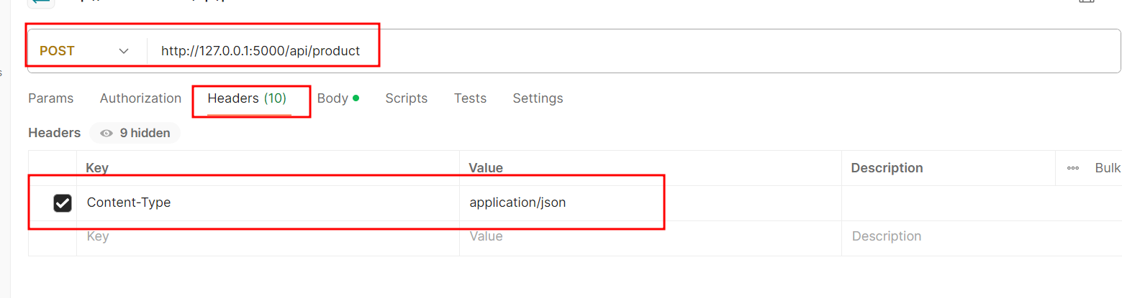

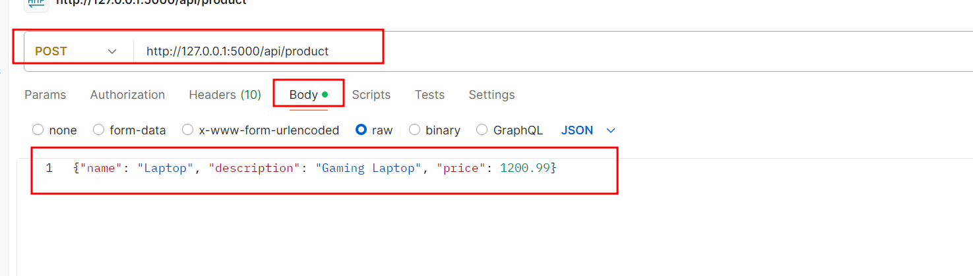

* 1. view all product data

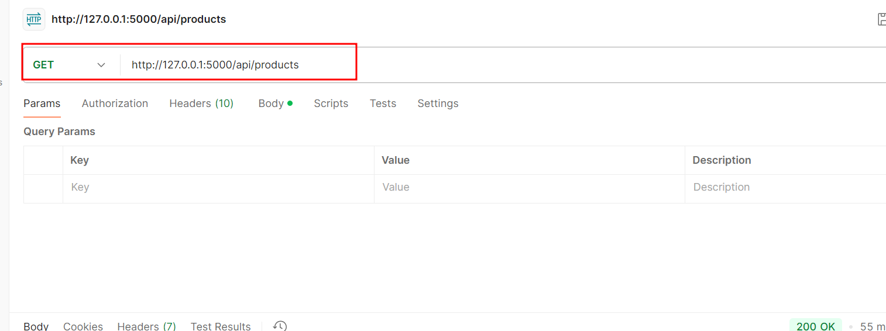

* 1. view particular product data using pid

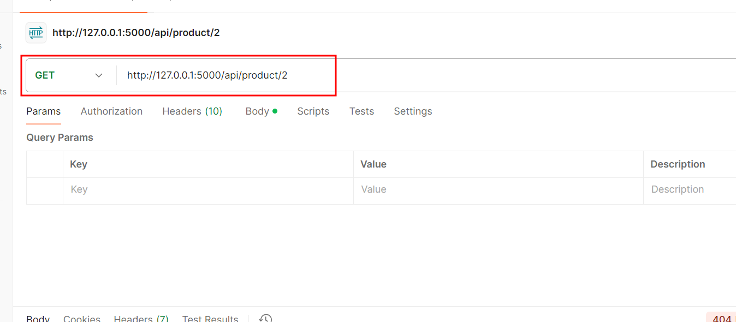

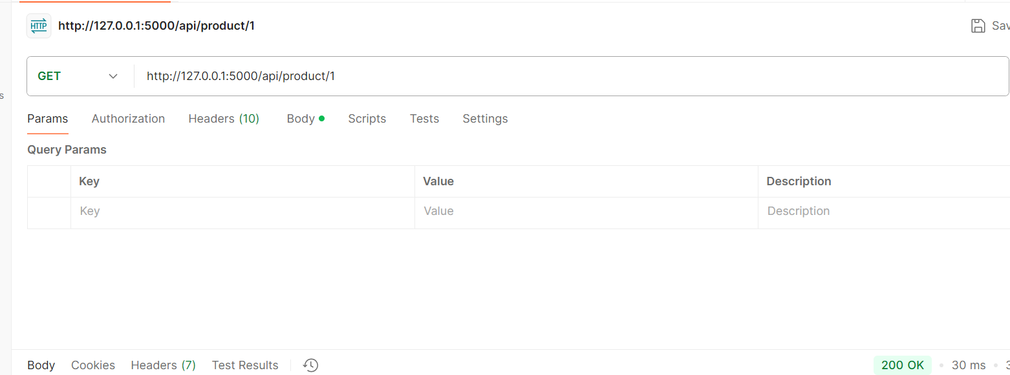

* 1. update the product details

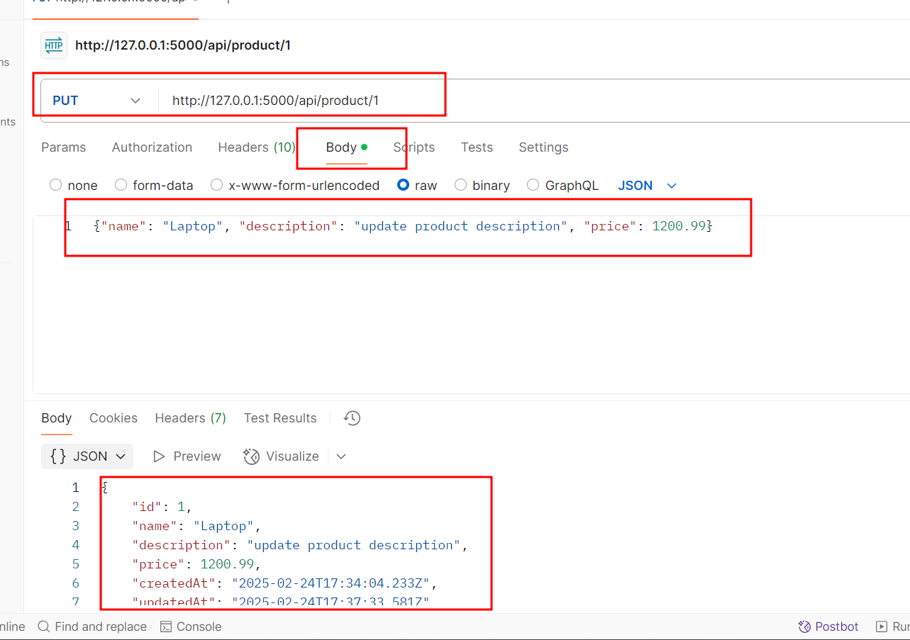

* 1. Delete the product

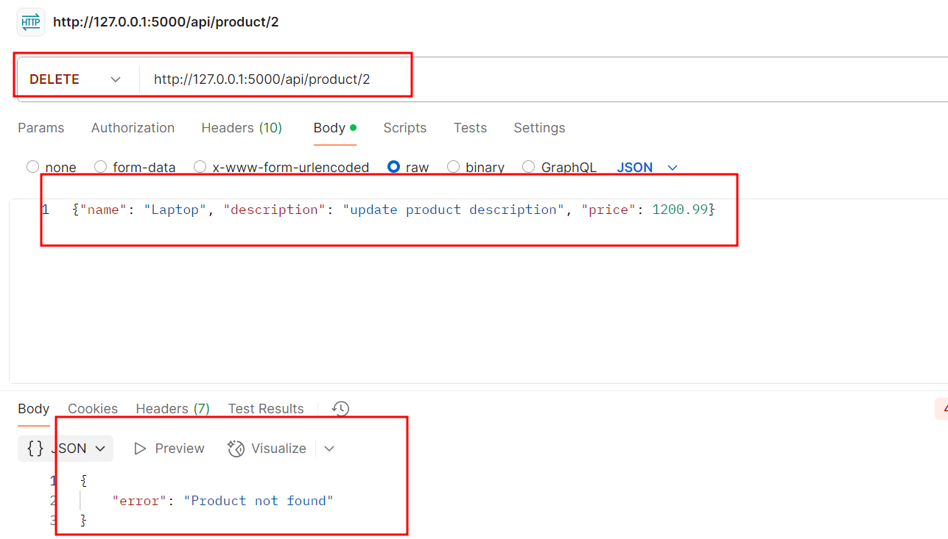

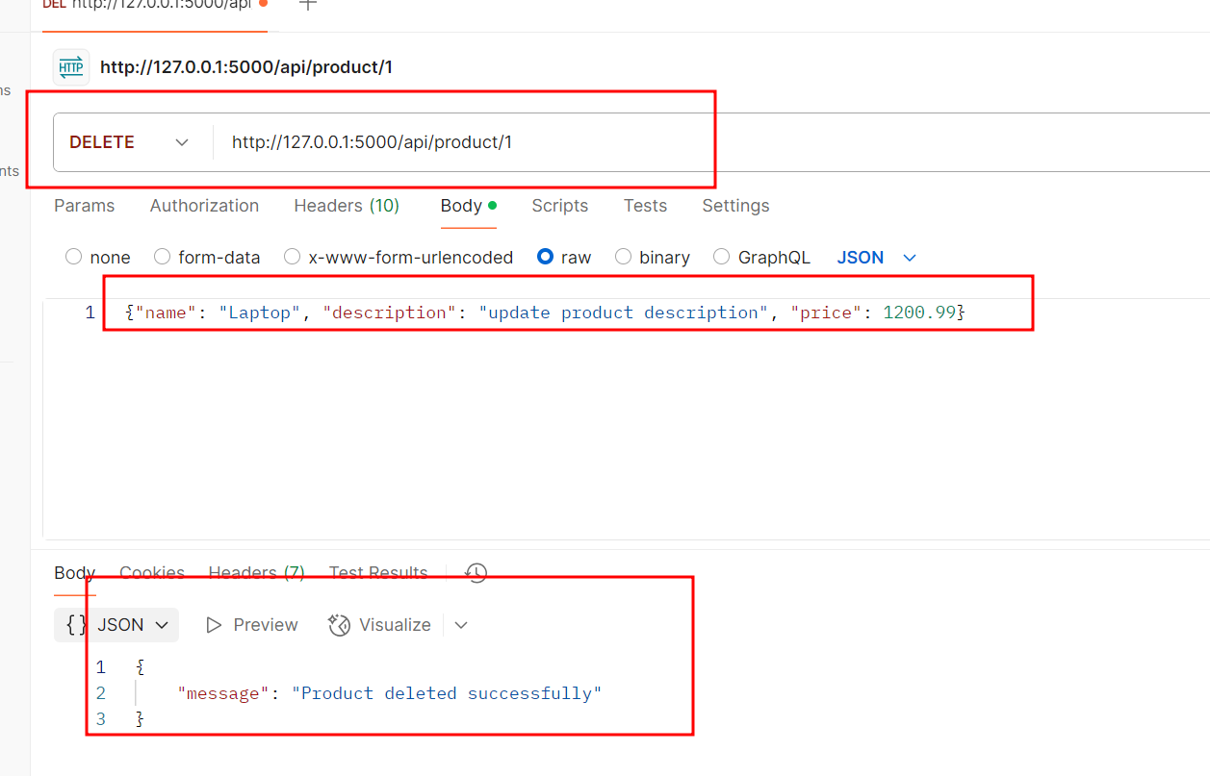

By following the outlined steps, you have successfully migrated the python flask functionality node js express js framework using GitHub Copilot, ensuring a successful transition while maintaining the integrity and functionality of the REST API system.